



**UNIVERSITY OF THESSALY -**

**INTERNATIONAL HELLENIC UNIVERSITY**

**Department of Economics (UTH)**

**Department of Physics (UTH)**

**Department of Physics (IHU)**

**Interdepartmental Postgraduate Program: *«Econophysics – Financial Forecasting»***

PROJECT FOR COURSE: **NEURAL NETWORKS IN FORECASTING – CHAOS THEORY IN ECONOMICS**

GRADUATE STUDENT:

**ADAMADIOS MAROULIS, GRIGORIOS RIGAKIS**

SUPERVISING PROFFESSORS:

**DR. STAVROS STAVRINIDIS, DR. MICHAEL CHANIAS**

2022 - 2023

Contents

Abstract 2

Introduction 3

Section 1 4

Section 2 9

FFT AND POWER SPECTRUM 11

ATTRACTOR 13

Section 3 16

CORRELATION DIMENSION 18

LYAPUNOV EXPONENT 19

ENTROPY 20

HURST EXPONENT 20

Section 5 21

THEORY 21

Prediction 22

Conclusion 24

References 25

Abstract

Neural network is presumed to be the inevitable outcome of the swift development of artificial intelligence. Based on the Mackey-Glass equations system a presentation of real phase portraits and phase spaces is considered to be useful in order to extract valuable results, while qualitative and quantitative analysis is made for a time series of the system with the aim of studying the Mackey-Glass system in-depth. Neural networks provide intuitive but effective approaches to chaotic forecasting, while the forecasting efficiency is a lot higher. Moreover, the parameters of the proposed approach are optimized, and the relatively optimized parameters are obtained after a large number of data experiments (number of inputs -hidden layer, number of neurons).

Keywords: Mackey-Glass, Neural network, forecasting, real phase portraits

# Introduction

The goal of this paper is to examine the Mackey-Glass equation system and make an in-depth analysis in its time series. While this widely known in mathematics and mathematical biology system has various use cases our goal is to observe its chaotic behaviour and try to interpret it. In 2021 Bartha, Krisztin and Vigh reported a number of phenomena observed obtained by systematic numerical investigation of a paradigmatic delayed feedback system, Mackey-Glass, while Li and Li in 2022 successfully applied HAF-LIESN and CAF-LIESN to chaotic time series MG with great results in forecasting.

Our paper is divided in 5 sections, in section 1 a pre-process is being made while phase diagrams and time series are presented while in section 2, we conduct qualitative analysis (from a time series of a system) while we create a power spectrum and reconstruct the equivalent phase space. Furthermore, generation of phase portrait and the deposition of the equivalent attractor in phase space is accomplished. In section 3, quantitative analysis is presented while correlation dimension, Lyapunov exponents, Kolmogorov entropy and Hurst coefficient are calculated. Ιn section 4, utilizing neural networks forecasting is accomplished while the parameters of the proposed approach are tested and explained. Lastly, in section 5, we predict 2 steps ahead of a specific time series of the system while specifying parameters for the sample using neural network. We utilize various programmes to obtain our results, such as Fractan, a mathematical software, Python a widely known coding language and Weka, a machine learning software program, widely used for data mining tasks.

# Section 1

The Mackey-Glass chaotic time series is generated by the following nonlinear time delay differential equation:

$\frac{dx(t)}{dt}=\frac{βx(t-τ)}{1+x^{n}(t-τ)}+γx\left(t\right)$*,*

where $β, γ, τ$  and $n$  are real numbers. Depending on the values of the parameters, this equation displays a range of periodic and chaotic dynamics. Such a series has some short-range time coherence, but long-term prediction is very difficult.

Originally, Mackey and Glass proposed the following equation to illustrate the appearance of complex dynamics in physiological control systems by way of bifurcations in the dynamics:

$\frac{dx}{dt}=\frac{βx_{τ}}{1+x_{τ}^{n}}-γx$ $, γ,β,n > 0$*,*

They suggested that many physiological disorders, called dynamical diseases, were characterized by changes in qualitative features of dynamics. The qualitative changes of physiological dynamics corresponded mathematically to bifurcations in the dynamics of the system. The bifurcations in the equation dynamics could be induced by changes in the parameters of the system, as might arise from disease or environmental factors, such as drugs or changes in the structure of the system.

The Mackey-Glass equation has also had an impact on more rigorous mathematical studies of delay-differential equations. Methods for analysis of some of the properties of delay differential equations, such as the existence of solutions and stability of equilibria and periodic solutions, had already been developed.

However, the existence of chaotic dynamics in delay-differential equations was unknown. Subsequent studies of delay differential equations with monotonic feedback have provided significant insight into the conditions needed for oscillation and properties of oscillations.

For delay differential equations with nonmonotonic feedback, mathematical analysis has proven much more difficult. However, rigorous proofs for chaotic dynamics have been obtained for the differential delay equation $\frac{dx}{dt}=g(x\left(t-1\right))$ for special classes of the feedback function $g$ .

Furthermore, although a proof of chaotic dynamics in the Mackey-Glass equation has still not been found, advances in understanding the properties of delay differential equations is going on, such as (L. Glass and M. C. Mackey 2010), that contain both exponential decay and nonmonotonic delayed feedback (G. Röst and J. H. Wu 2007). The study of this equation remains a topic of vigorous research.

The Mackey-Glass chaotic time series prediction is a very difficult task. The aim is to predict the future state $x(t+ΔΤ)$ using the current and the past time series $x(t)$, $x\left(t-1\right),…,x\left(t-n\right)$ (Figure 1). Until now, there are many literatures about the Mackey-Glass chaotic time series prediction, Awad and Pomares proposed a new approach of clustering to predict time series using the RBF neural networks in 2009. However, as far as the prediction accuracy is concerned, most of the results in the literature are not ideal.

Figure 1

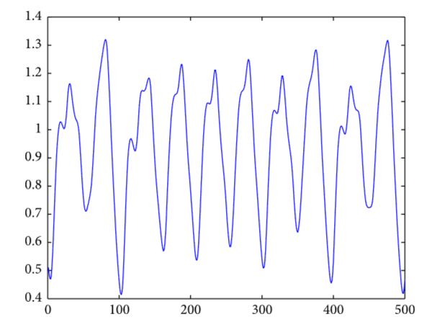

Mackey-Glass chaotic time series.

We chose different values for our parameters to visualize our time series. Figures 2 – 4 represent the time series with different values for tau ( $τ)$ in a sample containing ten thousand days (time).

Figure 2

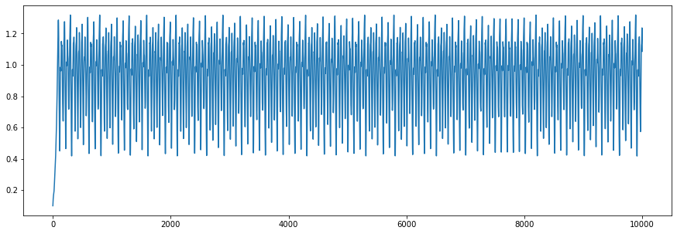

Time series generated from the Mackey–Glass equations. Tau = 17

$$β=0.2$$

$$γ=0.1$$

$$n = 10$$

$$tau = 17$$

Figure 3

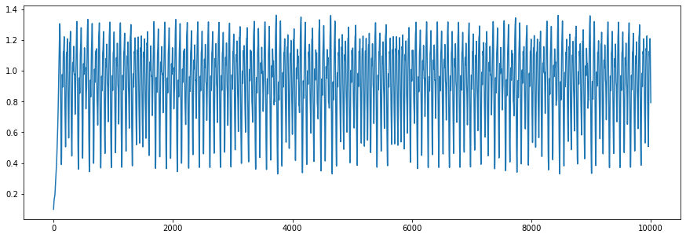

Time series generated from the Mackey–Glass equations. Tau = 20

$$β=0.2$$

$$γ=0.1$$

$$n = 10$$

$$tau = 20$$

Figure 4

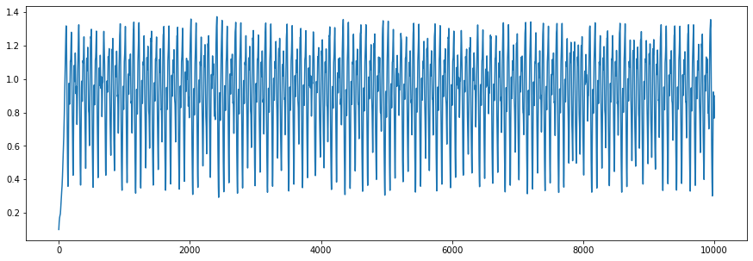

Time series generated from the Mackey–Glass equations. Tau = 22

$$β=0.2$$

$$γ=0.1$$

$$n = 10$$

$$tau = 22$$

In order to have a better understanding of the graph Figure 5 shows the same time series ( Tau = 22 ) in its first 800 days.

Figure 5

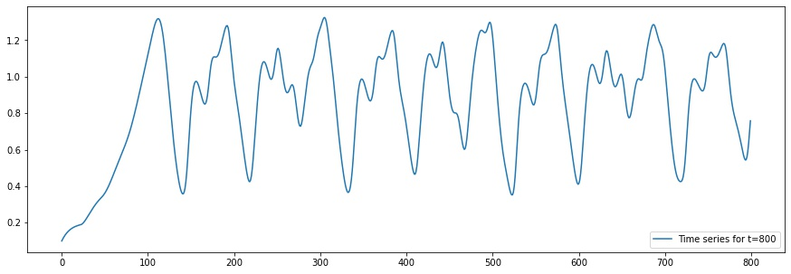

Β

Α

Time series generated from the Mackey–Glass equations. Tau = 22

These figures show that bifurcation diagrams for delay-differential equations may also contain isolated branches, namely single branches that begin or end quite abruptly for specific parameter values. Examples of isolated branches beginning suddenly are the ones labelled A and B in Figure 5.

To understand them, we study the time evolution of the solutions before and after the discontinuities, for the values of τ indicated by the vertical line segments

Figure 5 shows the time-evolution of $x(t)$ for τau = 22, namely for a value far from the beginning of branch B. In this case $x(t)$ is characterized by a smooth periodic oscillation with a single peak A within the period. For τ = 125, just before the beginning of B, the oscillation remains periodic but starts to develop an inflexion point B as indicated in the diagram above.

Moreover, phase space diagrams are shown below in figures 6 - 8 for different initial conditions values.

Figure 6

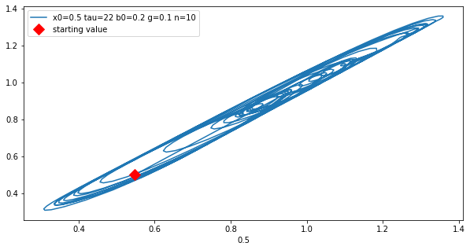

Figure 7

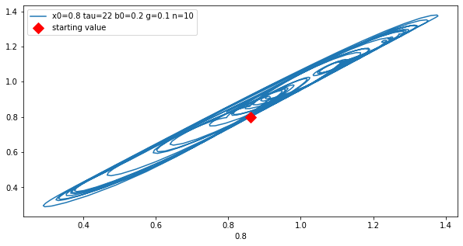

Figure 8

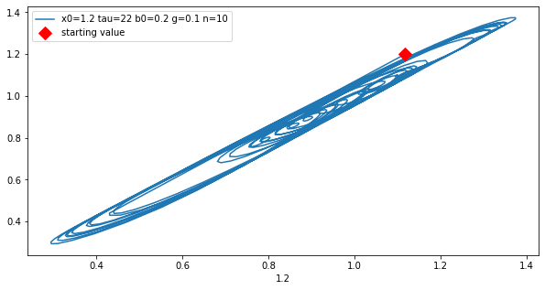

The diagrams above are representing the phase diagrams of the same equation but with different initial values. We are starting with $X_{0}=0,5$ and we go on with $X_{0}=0,8$ and $X_{0}=1,2$ while all the other parameters remain the same. Of course, the diagrams indicates the first 800 values in time in order to comprehend the diagram better in visual terms.

One can observe that even though the initial conditions are different the movement is still periodic and remains in the same trajectory. Periodic solutions of this system were shown to display continuous deformations of their waveforms as control parameters are varied. Such deformations create and destroy peaks in the oscillatory patterns. Peak creation and destruction results in rich and intricate isolated branches appearing and disappearing in bifurcation cascades.

# Section 2

In this section a qualitative analysis of the Mackey-Glass equations was performed. The qualitative analysis was separated in 3 major sections:

* Analysis of the Time Series in the frequency space, using FFT Transforms. The Power Spectrum was produced from this analysis.
* Reconstruction of the phase space of the Time Series
* Embedding of the attractor of the specific Time Series chosen in the phase space.

The Time Series chosen follows the equations proposed in the previous chapters using the following parameters: $τ=22, { β}_{0}=0.2, γ=0.1, and n=10$ as well as the initial condition $Q_{t_{0}=0}= 0.1$. The parameters were chosen to ensure that a “chaotic” behavior can be observed. The results of this section were produced using Python version 3.10, as well as MATLAB and Mathematica.

As stated above the first part of the analysis involves the production and analysis of the power spectrum of the Time Series. To get the power spectrum though, one must first obtain the Fourier Transform of the Time Series. The Fourier Transform of a Time Series is a rather trivial matter at this point, but is quickly defined at this point according to (Masen & Gripaios, 2009).

Assume a function $f\left(x\right), x∈(a,b)$. The integral transform of the function is defined as $$F\left(s\right)≡T\left\{f\left(x\right)\right\}≡\int_{a}^{b}{f\left(x\right)K\left(s,x\right)dx} \left(1\right)$$

Equation 1

where $K\left(s,x\right)$ is called the kernel function. The Fourier Transform of the function $f\left(x\right)$ can then be defined as the integral transform, whose kernel function is $K\left(s,x\right)≡\frac{1}{\sqrt{2π}}e^{-isx}$, or $$F\left(s\right)≡F\left\{f\left(x\right)\right\}=\frac{1}{\sqrt{2π}}\int_{-∞}^{+∞}{f\left(x\right)e^{-isx}dx} \left(2\right)$$

Equation 2

This definition can be modified for Discrete Time Series where we instead use the Fast Fourier Transform (FFT) algorithm (Cooley & Tukey, 1965) to calculate what the Discrete Fourier Transform (DFT), which is defined as below $$F\left\{x_{n}\right\}= X_{k}= \sum_{n=0}^{N-1}{x_{n}e^{-\frac{i2π}{N}kn}}=\sum_{n=0}^{N-1}{x_{n}\left[\cos\left(\frac{2π}{N}kn\right)-isin\left(\frac{2π}{N}kn\right)\right]} \left(3\right)$$

Equation 3

where in $X_{k}=F\left\{x_{n}\right\}$, $x_{n}$ is the original Discrete Time Series of length $N$ and $X_{k}$ is the DFT of $x_{n}$.

The Fourier Transform is generally used, to describe to what extent certain frequency signals of smaller intensity, make up the function $f\left(x\right)$ which is being analyzed at the time. In the same sense, the power spectrum of a function $S_{xx}$, describes how much power is each of these single frequency signals carries. Following from the well-known definition of the energy density of a signal, which can be shown to be $$E ≜ \int_{-∞}^{+∞}{{\left|x_{n}\right|}^{2}dt}= \int_{\left(-∞\right)}^{\left(+∞\right)}{{\left|X_{k}\right|}^{2}dt} \left(4\right)$$

Equation 4

where the second equation comes from Parseval’s Theorem (Masen & Gripaios, 2009). According to our definition of the DFT, this means that the power spectrum of a Discrete Time Series should be defined as $$S_{xxk}=\lim_{N→∞}{{(Δt)}^{2}{\left|\sum_{n=0}^{N}{x_{n}e^{-\frac{i2π}{N}knΔt}}\right|}^{2}} \left(5\right)$$

Equation 5

assuming as before a Discrete Time Series $x_{n}$ of length $N$. According to the class notes, this spectrum is expected to be a broadband spectrum for chaotic time series, since any other result implies that the time series is noise-free and periodic.

As for the second part of this analysis, phase space reconstruction and embedding of the attractor in phase space was performed. According to (Takens, 1981), it is possible for systems of Discrete Time Series to create a phase space of m dimensions, where each observed dimension of the system $Y_{i}$ can be expressed as: $${\vec{Y}}_{i}=\left(Y_{i}, Y_{i+τ}, Y_{i+2τ}, …, Y_{i+\left(m-1\right)τ}\right) (6)$$

Equation 6

where $τ$ is known as the embedding delay.

The most well-known method for choosing the number of dimensions $m$ and the embedding delay $τ$ is the False Nearest Neighbour method, proposed by (Kennel, Brown, & Abarbanel, 1992). In this method, the distance between neighbouring points is first considered in an $m$ dimensional space, and then in an $m+1$ dimensional space. If this distance grows too much, then the neighbours are false. The proper number of dimensions is the number $m$ for which an $m+1$ embedding labels more than a threshold percentage of neighbours as false, usually around 10%. The time lag is then chosen, based on the length of the Discrete Time Series.

## FFT AND POWER SPECTRUM

The time proposed in section 1, with the parameters shown above, produce the

Figure 9

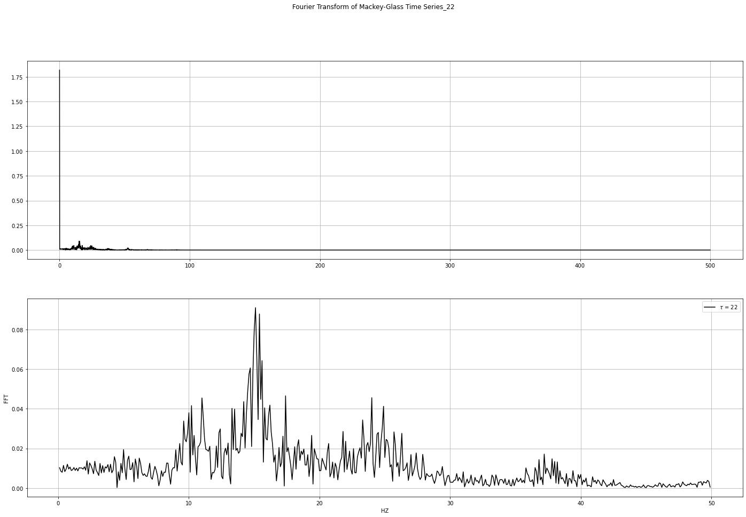

following FFT. For the calculation of the FFT, a time step of 0.001 was assumed.

In this image the same plot is shown, first whole, then only for the first 500 data points, while ignoring the first spike. This is done to better show how the Fourier Transform changes as the frequencies increase, seeing as how in the first image, it seems to rapidly decrease to 0, while that is not necessarily the case, as is shown by the spikes present in certain  
frequencies before 20 Hertz. Similarly in the above image we see the power spectrum for the same Fourier Transform.

Unlike the Fourier Transform these decreases quite rapidly towards 0, with highest spike reaching only 0.008. These results indicate a chaotic behavior, since a non-chaotic behavior would produce clean spikes in certain frequencies, without any noise, especially considering the time series was produced artificially from the solution of the DDE.

Figure 10

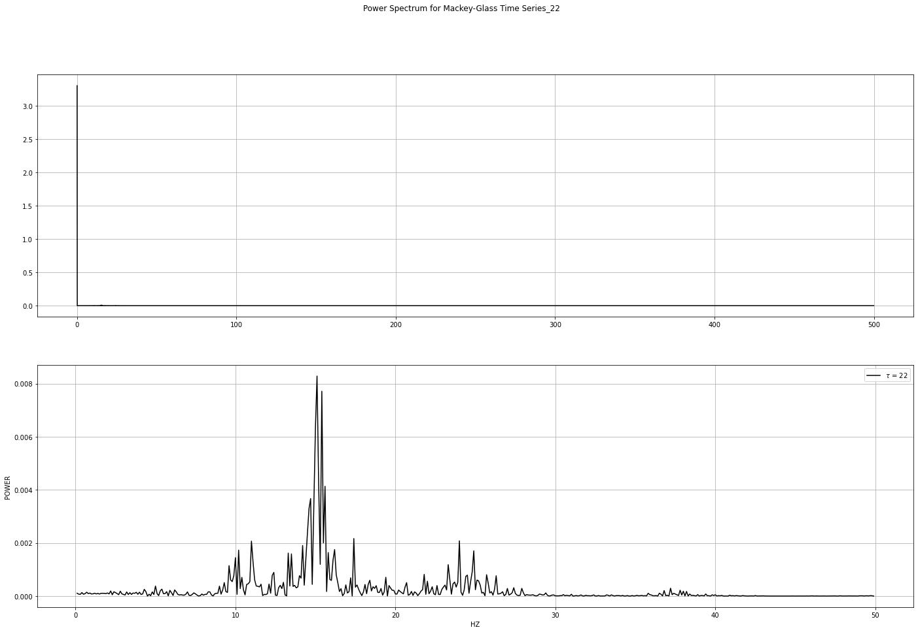

## ATTRACTOR

Through the program MATLAB, a reconstruction of the phase space was performed, to determine the optimal time lag, as well as the minimum embedding dimension for the system, as is shown in the following image. In this image, we can see the projections of the 3D attractor, as well as some statistics for the values of the time series. These same projections are better shown below in the following images. By our calculations, the estimated optimal time lag of the system is $τ'=7$, and the minimum embedding dimension is $dim=3$.

Figure 11

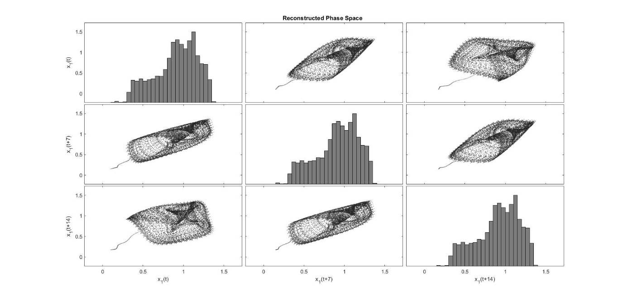

Figure 12

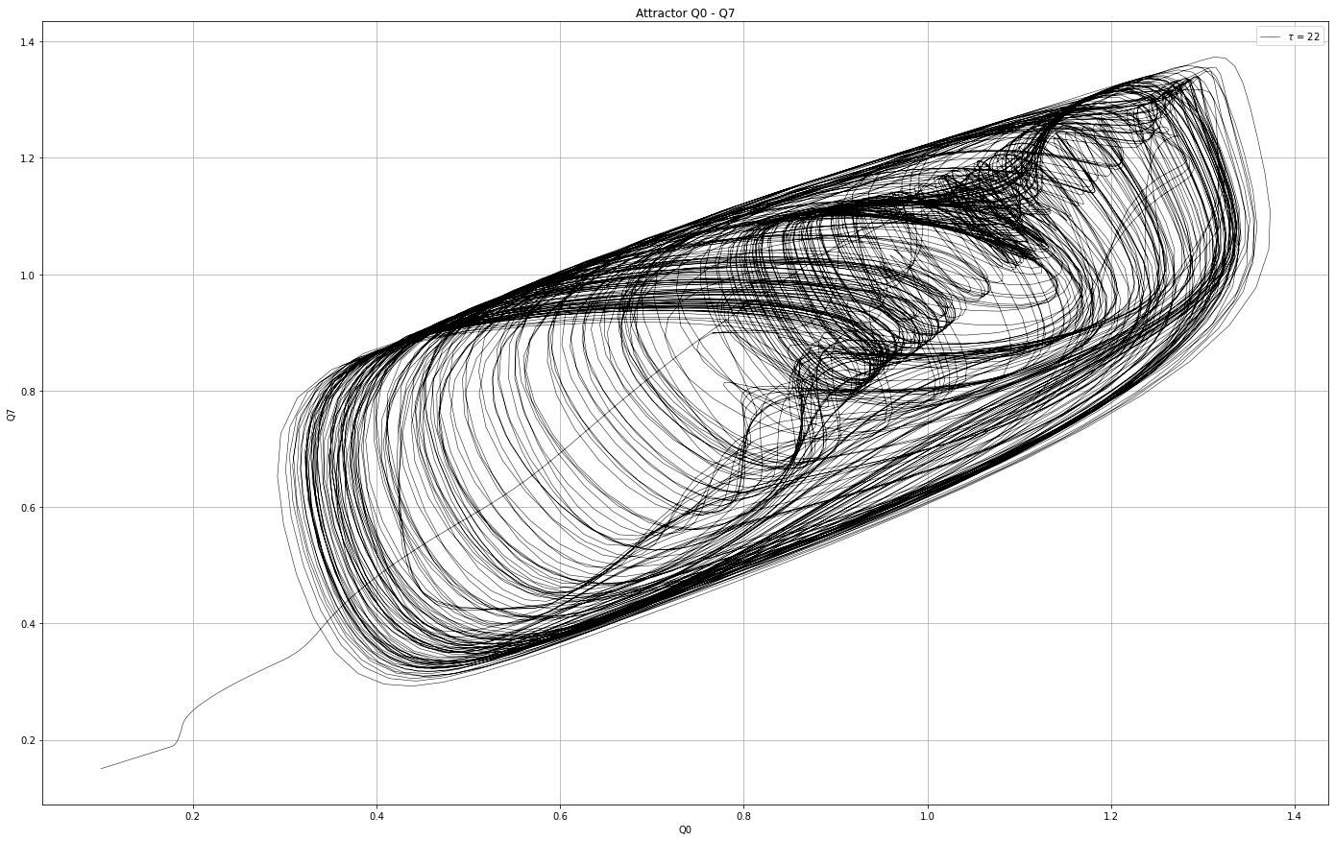

The projections of the attractor, contain the values $Q_{t+τ'}$ and $Q_{t+2τ'}$ plotted against the value $Q$ for each time step, where in this case $τ^{'}$ is the optimal time lag, as calculated by MATLAB.

Figure 13

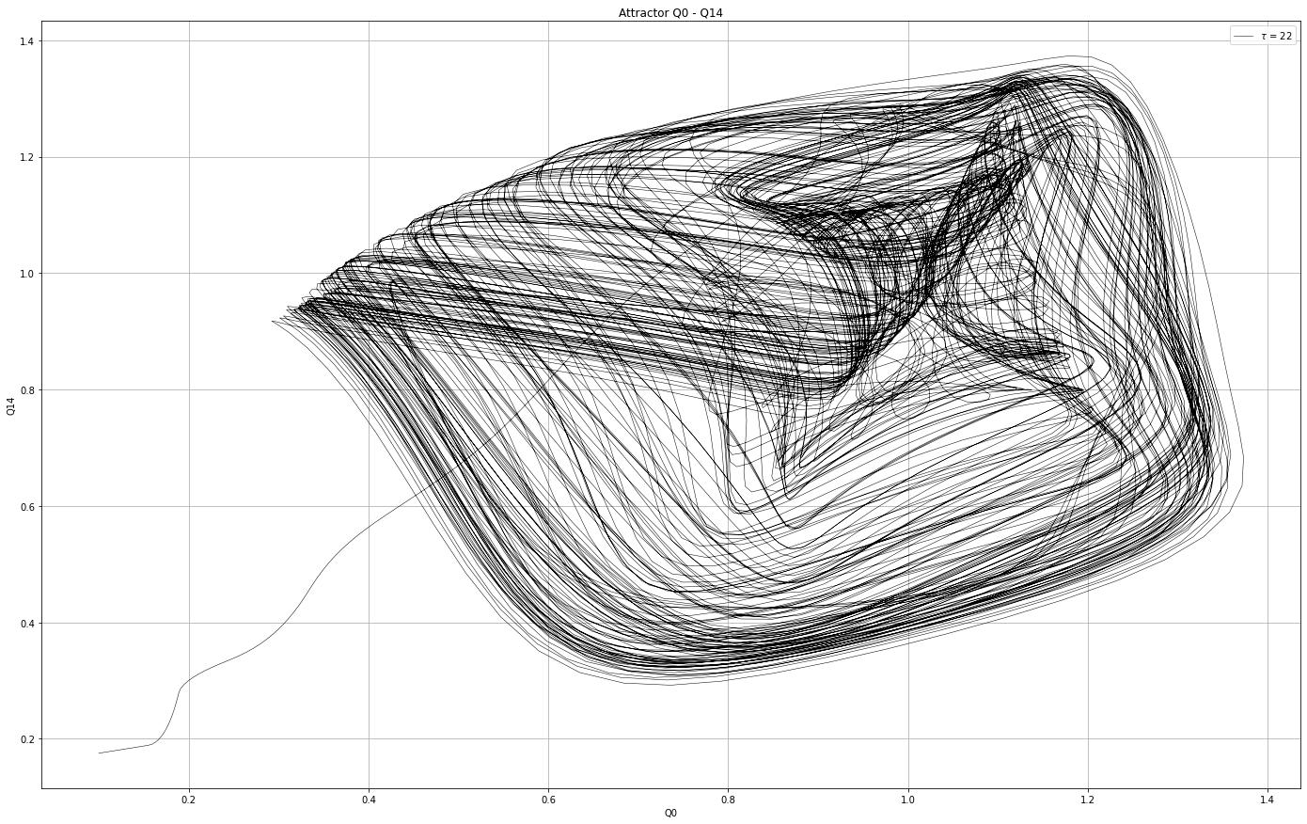

The time lag is neither too small nor too big, indicating that there is not too much noise introduced to the system, and that the attractors do in fact represent the dynamics of the system. This is to be expected, since this is an artificially produced system, rather than a real measured time series. The foldings seen in the 2D projections of the attractor, as well as it’s generally erratic behaviour, are good indicators of chaos in our system, as is expected based on the literature.

Figure 14

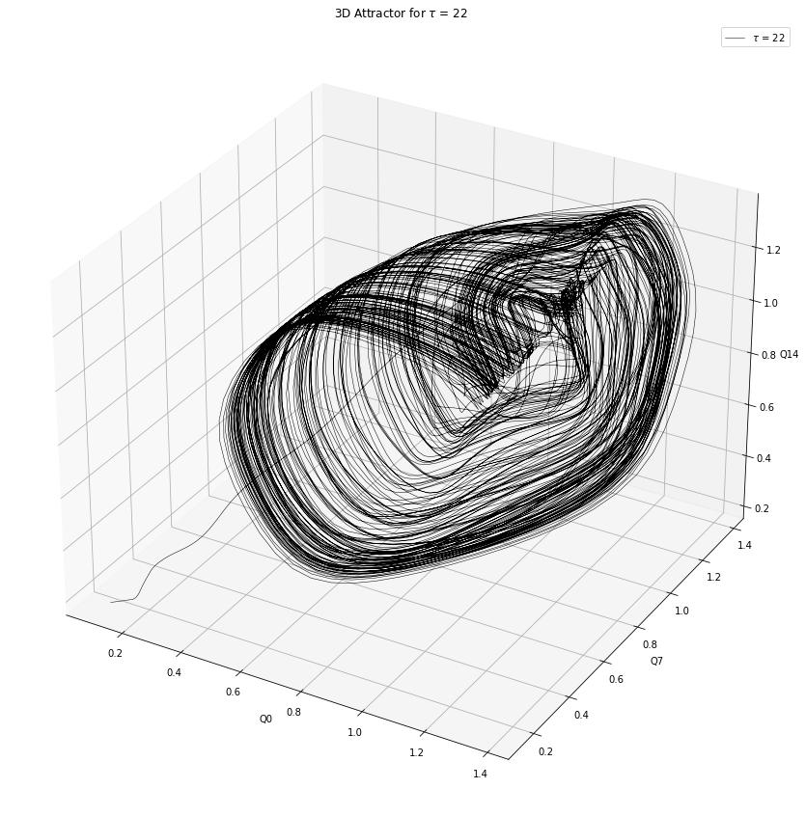

# Section 3

In this chapter the non-linear analysis of the time series is continued, through the calculation of important metrics for the Discrete Time Series. These metrics include the Correlation Dimension, the Lyapunov Exponents, the Kolmogorov Entropy and the Hurst Exponent of the Time Series, all of which are presented below.

To start off we calculated the Correlation Dimension of the Discrete Time Series. The Correlation Dimension is a measure of the dimensionality of the space that a number of points occupies. This is expected to be non-integer, or a fractal dimension, assuming that the Time Series is chaotic. For a m-dimensional Discrete Time Series, this is defined as follows.

Let $x_{n}$ be a Discrete Time Series of $N$ points in time $t$. We can then write: $$x_{n}≡\left\{\vec{x}\left(i\right): \vec{x}\left(i\right)=\left[x_{1}\left(i\right),x_{2}\left(i\right), x_{3}\left(i\right), …, x_{m}\left(i\right)\right]\right\}, i=1, 2, 3, …, N \left(7\right)$$

Equation 7

and $$C\left(ε\right)= \lim_{N→∞}{\frac{g}{N^{2}}} \left(8\right)$$

Equation 8

where $C(ε)$ is the Correlation Integral, and $g$ is the number of pairs points with distance less than $ε$. This definition is presented by (Grassberger, 1983). For small values of $ε$ and as $N→∞$, the Correlation Dimension is expected to approximately become an exponential function $C\left(ε\right)= ε^{ν}$. This number $ν$ can then be estimated and is generally expected to be a non-integer.

Similarly to the Correlation Integral, the Lyapunov Exponent is also an indirect measure of the chaos which exists in a dynamical system. Whereas the first measures the dimensionality of the space occupied, the second measures the rate with which neighboring trajectories separate from one another as the system evolves over time. The idea has been shown in many papers and works, so we will be using the class notes to present the notion.

Assume two neighboring points at time $t$ whose distance should be $ε$. These two points $x_{0}$ and $x_{0}+ε$ define a vector ${δZ}_{0}$, which we will call the separation vector. After the system evolves for $N$ time steps, the separation vector’s length should evolve at a rate $$\left|δZ \left(t\right)\right|= e^{λt}\left|{δZ}_{0}\right|$$ 
where $λ$ is the Lyapunov Exponent. Since the actual value of the exponent depends on the initial orientation of the vector, the metric calculated is considered to be the Maximal Lyapunov Exponent (MLE). For this number we consider the following cases. If $λ<0$ then the system converges and is not chaotic. If $λ=0$ then the distance vector is unchanging over time. If $λ>0$ then the system is chaotic, with the Exponent serving as a measure of chaos.

For this report, MATLAB was used to calculate the Lyapunov Exponents, following the method proposed by (Rosenstein, Collins, & De Luca, 1993). In this method, after a phase space reconstruction is performed, through the use of the delay method, the nearest neighbors are estimated, and from them we calculate the Lyapunov Exponent, by fitting a line to the separation of the data through the use of the least squares.

For the next step the system’s entropy was calculated. There are many different definitions of entropy depending on which metric of order is considered. For example, Approximate Entropy measures the predictability of the system based on how orderly the system is.

Another important measure of Entropy is the Kolmogorov Entropy. Also known as metric entropy, this measures whether a randomly chosen trajectory will be in a specific D-dimensional hypercube of the phase space. To be more specific, assuming a phase space divided into D-dimensional hypercubes of content $ϵ^{D}$, one can define the Probability that a trajectory is in hypercube $i_{0}$ at times $t_{0}=0, t_{1}=T, t_{2}=2T, …$, as $P_{i_{0},…, i_{n}}$. We define $K_{n}=h_{k}= -\sum_{i_{0},…, i_{n}}{P_{i_{0},…, i_{n}}\ln\left(P_{i_{0},…, i_{n}}\right)}$, where $K_{N+1}- K_{N}$ is the information necessary for predicting which hypercube a specific trajectory will be in at $t=\left(n+1\right)T$, assuming we know the trajectories for all previous times. We then define the Kolmogorov Entropy to be $$K≡\lim_{T→0}{\lim_{ϵ→ -0^{+}}{\lim_{N→∞}{\frac{1}{NT}\sum_{n=0}^{N-1}{\left(K_{n+1}-K_{n}\right)} }}} \left(9\right)$$

Equation 9

which is also connected with the Lyapunov Exponents mentioned earlier through the Pesin Identity. This states that the Kolmogorov Entropy of a system is equal to the sum of positive Lyapunov Exponents of the system. While this Identity does not hold for every system, it can be assumed to always be true for this report.

For the last step of this report, the Hurst Exponent was calculated. In Chaos Theory, this is defined as measure of ‘randomness’ the chaotic series shows. If the Hurst Exponent is large, than the Time Series, while deterministic, appears to be extremely random, whereas if the exponent is small, then the Time Series is expected to be rather orderly, and have some form of ‘periodicity’. Based on the values, a Chaotic Series can be characterized as:

* Persistent, when $H>0.5$. This indicates a series with high long-term positive autocorrelation. These series have persistent trends, and tend to explode really quickly, i.e. they are rather volatile.
* Antipersistent when $H<0.5$. This indicates that the Time Series does not have long-term positive autocorrelation, and in fact tends to switch between high and low values. Thus a high value pair, will be followed by low values etc. These Series are characterized as ‘mildly chaotic’.
* When $H=0.5$ then there is nothing to be said for the autocorrelation in the long-term, or to rephrase this, the Time Series’ long term autocorrelation tends to 0.

For the Mackey – Glass Time Series, a low Hurst Exponent value is expected, since they tend to oscillate around an average value, rather than quickly and exponentially explode to either high or low values.

## CORRELATION DIMENSION

The Correlation Dimension was estimated through the Phase Space Reconstruction performed in Chapter 3. By estimating the slope of the Correlation Integral for small values, using the least mean squares method, an estimated value is 2.603288, as is shown in the plot below.

Figure 15

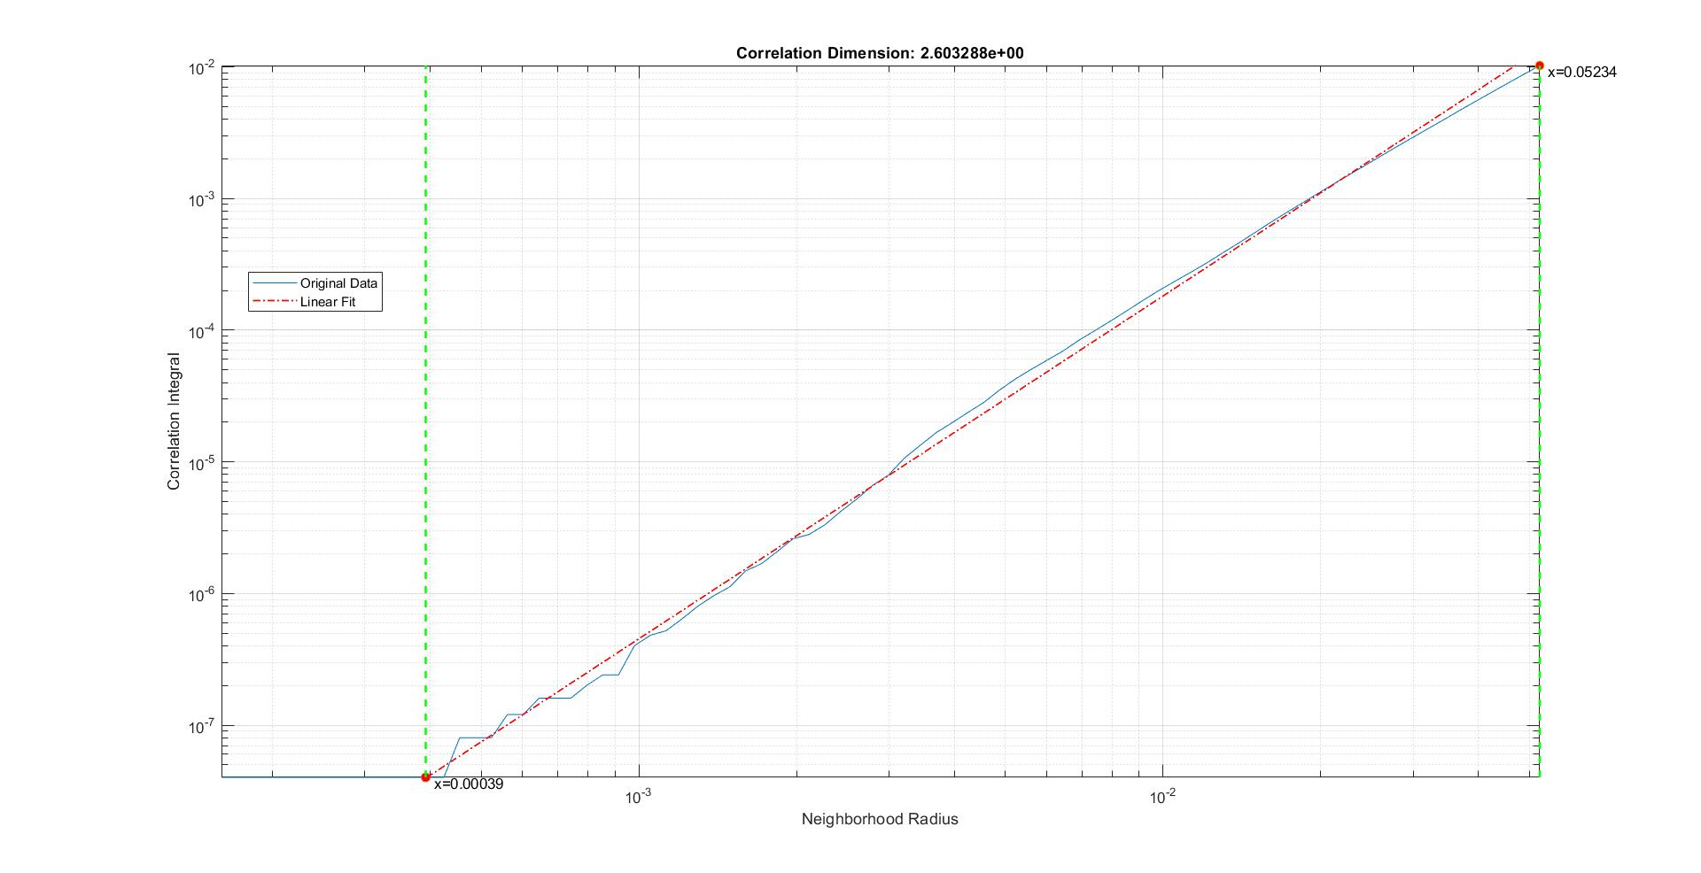

This value agrees with the one estimated by the program FRACTAN, shown to be about 2.625 in the following image. In this image, one can also see the plateau that begins to emerge around the embedding dimension $m = 2$, but which gets only smoother as the embedding dimension approaches $m=4$.

Figure 16

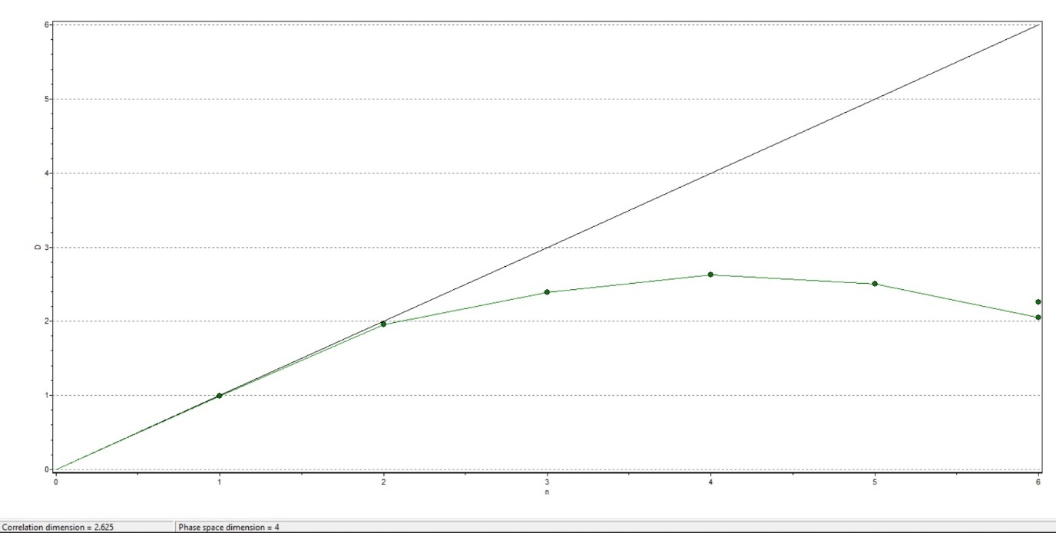

## LYAPUNOV EXPONENT

For the Lyapunov Exponent, the method proposed in the theory was followed. The relevant image produced by MATLAB, for a maximum expansion range of 200 is shown below. As can be seen in the plot, the Maximal Lyapunov Exponent is calculated to be approximately 0.0554.

Figure 17

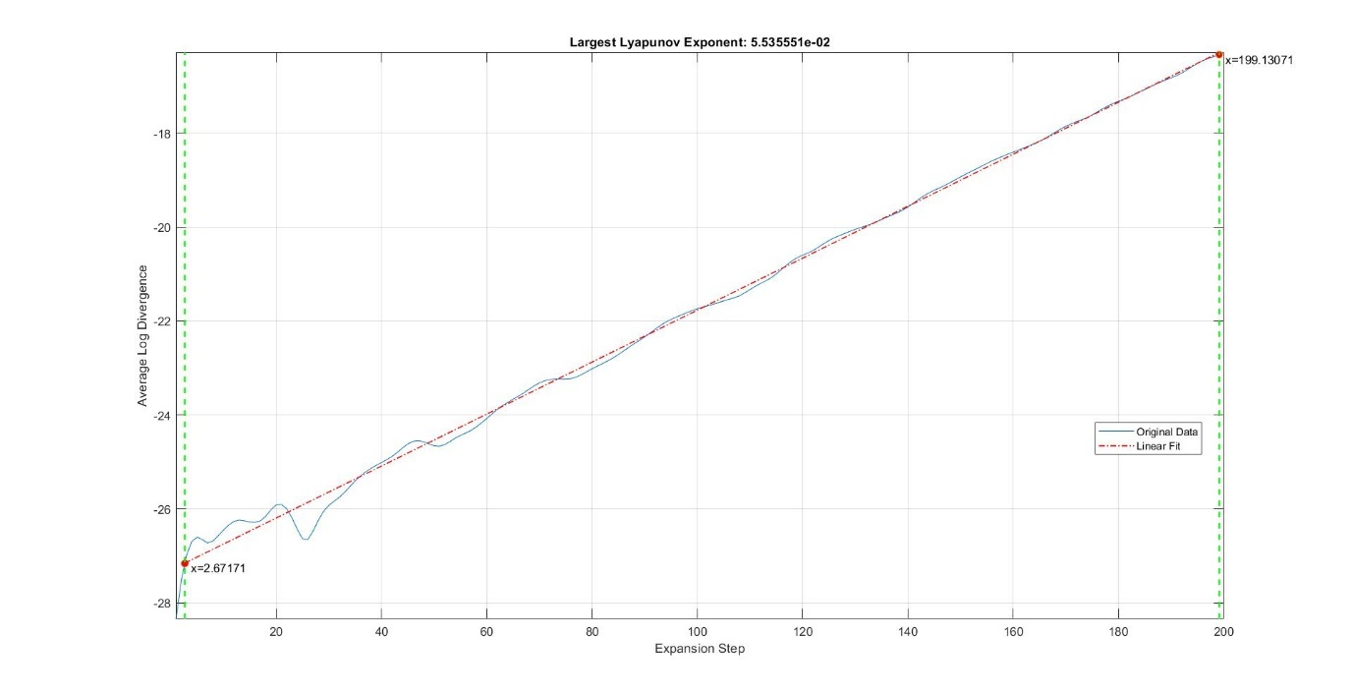

## ENTROPY

In order to estimate the Correlation Entropy of the system, FRACTAN was used producing the result that follows. In this plot we see that the Correlation Entropy is calculated to be approximately 0.265. In addition, MATLAB was used to calculate the Approximate Entropy of the system, which came out to be around 0.4699.

Figure 18

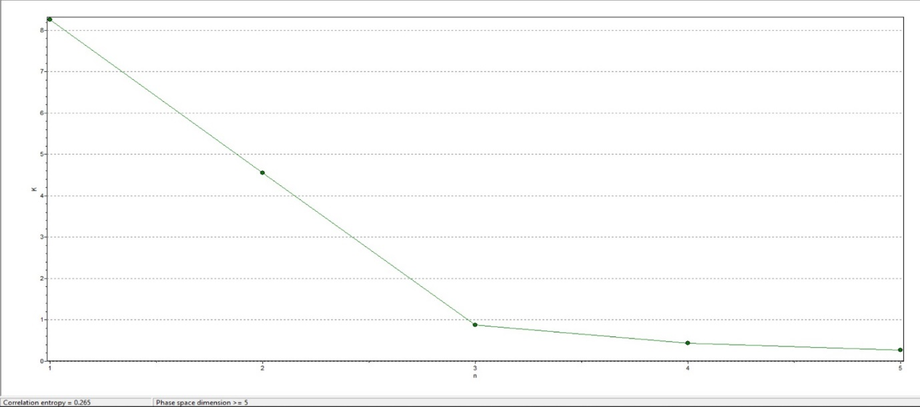

## HURST EXPONENT

The Hurst Exponent was also calculated through the use of the program FRACTAN and is approximately 0.2419. Considering that the value is positive but less than 0.5, this indicates that the Time Series is chaotic, but anti-persistent. In terms of Economics, this means that a market modelled as a Mackey – Glass system would probably be a sideways market.

Figure 19

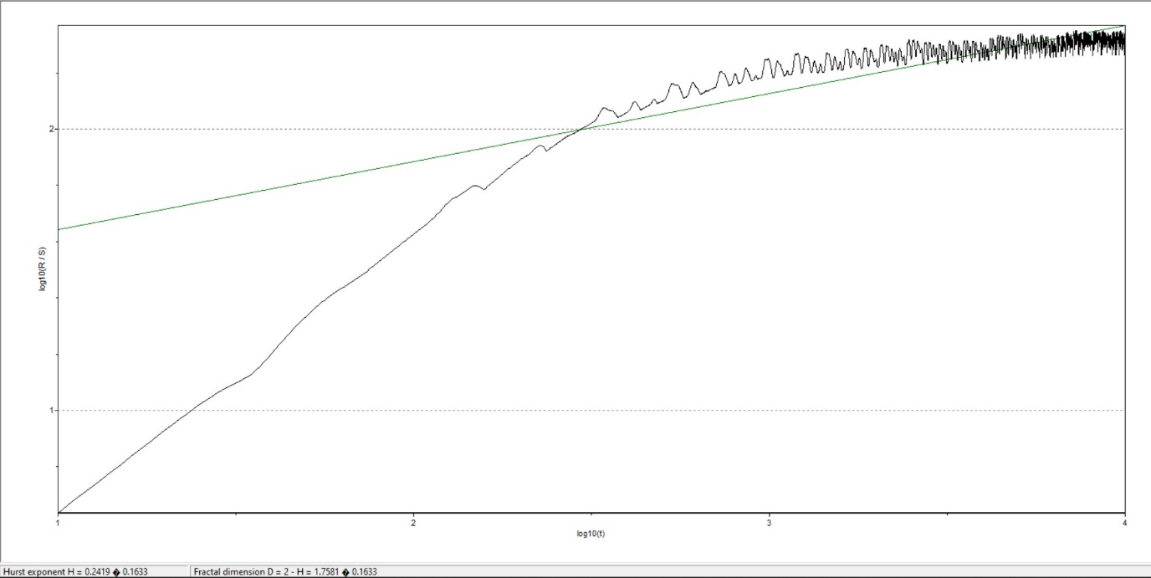

# Section 5

For the final part of this research, Neural Networks were used to forecast our Time Series for a certain number of steps. Weka was used for this part of the research to implement a Multi – Layer Perceptron Algorithm, with 1 or 2 hidden layers. These concepts are presented thoroughly in the following section

## THEORY

A Multi – Layer Perceptron Algorithm, or MLP for short, is a method were the data is passed through a number of neurons, which combine to create output for the next time step, meant to have the smallest error possible compared to the actual value. What essentially happens is that the actual Time Series is considered, along with the Time Step, and several lags. These entities are all considered to be the first layer of the network, or the input layer. The input layer linearly combines data given randomized weights, and passes it on to number of nodes, called the hidden layer. Each node in the hidden layer carries its own weights, and passes the data to the next step, known as the activation function.

The activation function ensures that the network is not just a series of linear combinations, but actually has a layer of complexity to it. What it does is it passes the results from the linear combination of data from the input layer into a function meant to transform the data in a specific way. Common examples of such activation functions are the Sigmoid function, the Hyperbolic Tangent (tanh) function etc. After getting results from the activation function $g()$, this process is repeated for each consecutive layer until the last. The last layer is the output layer, hopefully containing the optimized result of the network, while all layers in between are called hidden layers. The whole process described above is called forward propagation, where the data is allowed to propagate through the network, from beginning to end.

Since one cannot hope to achieve optimized results by using randomized weights and parameters in both the linear regression and the activation functions, this same process is then allowed to happen backwards, i.e. passing the results through the network from end to beginning, so that one can assess how to network deviates errs when analyzing the data. Once the errors are calculated, the weights are then adjusted based on parameters called the learning rate and the momentum. Once adjusted the network is tested a second time, then a third etc. until hopefully either a satisfying error value is reached, or the network has finished training a specified number of times, say for example 500. The process described above is called, backward propagation.

We chose a specific time series for our forecasting process namely the one with the following parameters: $x_{0}=0,1$ $tau=22$ $b_{0}=0,2$ $g=0,1$ $n=10$.

## Prediction

After carefully considering the parameters and estimating the hidden layers multiple times we ended up with the following parameters indicating the best results:

Two hidden layers with four and two neurons respectively.

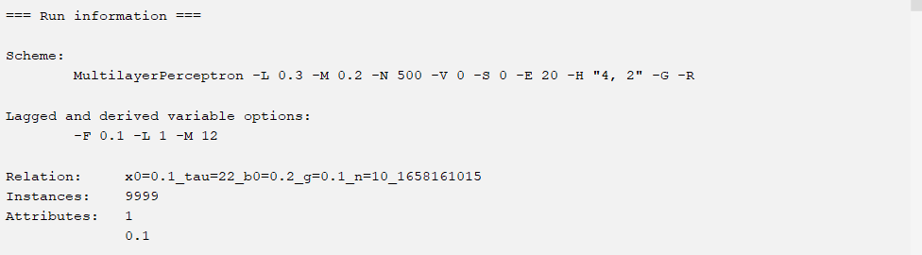

Those parameters indicated to provide the most accurate results for our prediction in terms of Mean Absolute Error (MAE) and Root Mean Squared Error (RMSE).

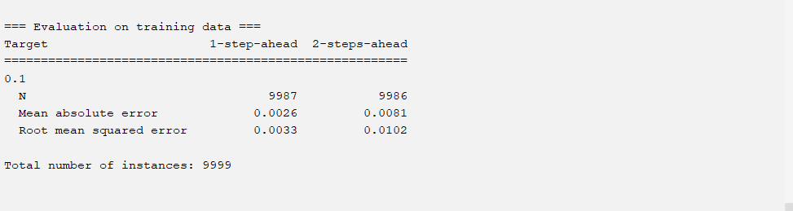

We can observe that for two steps ahead prediction the errors are quite low something that indicates that our prediction is pretty accurate. The sample was trained in 500 epochs which gave an error per epoch = 0,0000515 as we can see in the following diagram.

Figure 20

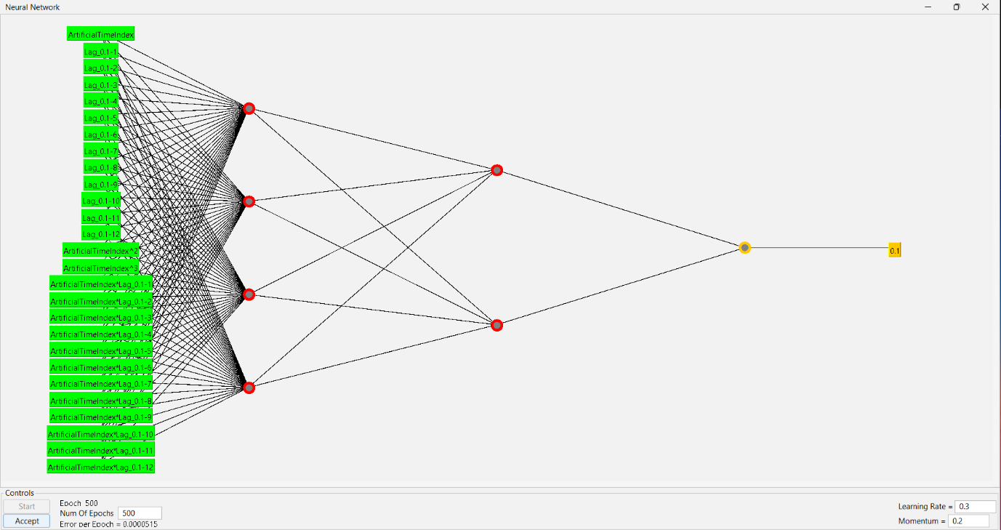

Furthermore, the prediction diagrams are presented for the first 2000 days and the last 1500 days. The red line indicates the actual prices while the blue indicates the prediction values.

Figure 21

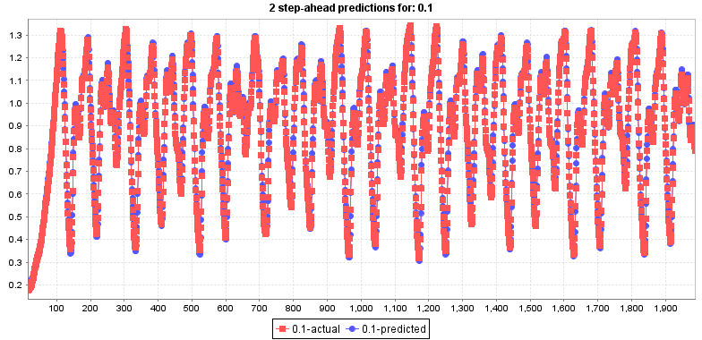

Figure 22

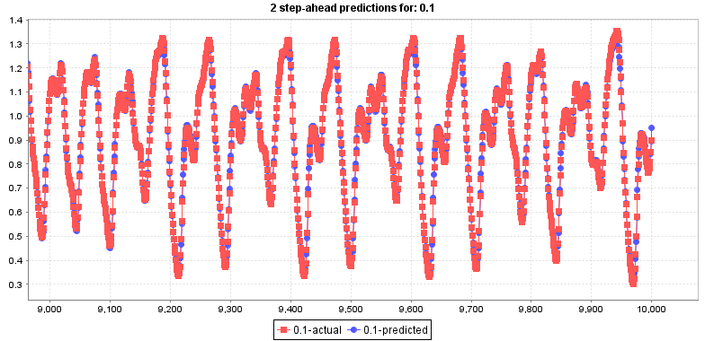

Lastly, the predicted values are presented as follows:

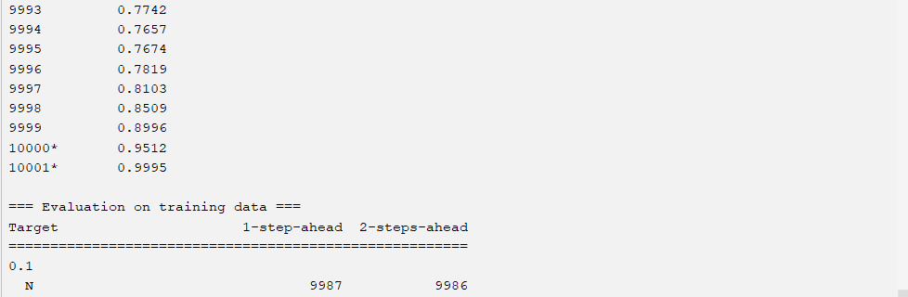

# Conclusion

Following the results produced above, we conclude that the Mackey – Glass System, is a ‘mildly’ chaotic system. It seems to be a plausibly good system for modelling systems, which either are known to have a strong autocorrelation for a specific time lag, or appear to have ‘chaotic seasonality’, i.e. they seem to oscillate between a maximum and minimum value in a chaotic manner.

It would be interesting to study, not only how this system can describe existing systems in fields outside physiology, such as economics, but also how this system changes properties when other terms are introduced in the differential equation. For example, one might add not only one time lag term in the equations development, but also a dependence on different time lags, or possibly an independent variable altogether. This could for instance, describe how certain variables, such as stock prices, are influenced by other variables but with a time lag, such as the S&P500 Index.

# References

L. Glass and M. C. Mackey, “Mackey-Glass equation,” Scholarpedia, vol. 5, no. 3, p. 6908, 2010.

G. Röst and J. H. Wu, “Domain-decomposition method for the global dynamics of delay differential equations with unimodal feedback,” Proceedings of The Royal Society of London.

Series A. Mathematical, Physical and Engineering Sciences, vol. 463, no. 2086, pp. 2655–2669, 2007

M. Awad, H. Pomares, I. Rojas, O. Salameh, and M. Hamdon, “Prediction of time series using RBF neural networks: a new approach of clustering,”

International Arab Journal of Information Technology, vol. 6, no. 2, pp. 138–143, 2009

Cooley, J. W., & Tukey, J. W. (1965). An algorithm for the machine calculation of complex Fourier series. Mathematics of computation, 297-301.

Grassberger, P. (1983). Generalized dimensions of strange attractors. Physics Letters A, 227-230.

Kennel, M. B., Brown, R., & Abarbanel, H. D. (1992). Determining embedding dimension for phase-space reconstruction using a geometrical construction. Physical review A, 3403.

Masen, S. H., & Gripaios, M. E. (2009). Mathematical Methods in Physics, Volume A. Thessaloniki: Aivazis Publications.

Rosenstein, M. T., Collins, J. J., & De Luca, C. J. (1993). A practical method for calculating largest Lyapunov exponents from small data sets. Physica D: Nonlinear Phenomena, 117-134.

Takens, F. (1981). Detecting strange attractors in turbulence. Dynamical systems and turbulence (pp. 366-381). Warwick: Springer.

Ferenc A. Bartha, Tibor Krisztin, Alexandra Vígh, Stable periodic orbits for the Mackey–Glass equation, Journal of Differential Equations

Leandro Junges, Jason A.C. Gallas, Intricate routes to chaos in the Mackey–Glass delayed feedback system, Physics Letters A, 2012

Yuting Li, Yong Li, Predicting chaotic time series and replicating chaotic attractors based on two novel echo state network models, Neurocomputing, 2022

Glass, L. Synchronization and rhythmic processes in physiology. Nature 410, 277–284 (2001).